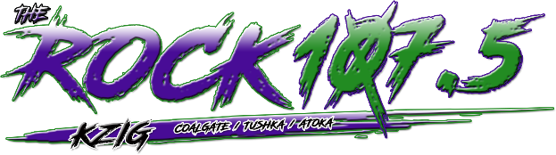
DIGITAL
ADVERTISING
ONLINE AT
KZIGRADIO.COM

Available Website Zone | Banner Size | Exclusive Monthly | Rotation Monthly
Header Leaderboard | IAB Rectangle (728x90) | $100 | $75
Homepage Leaderboard 1 | IAB Rectangle (728x90) | $75 | $50
Homepage Leaderboard 2 | IAB Rectangle (728x90) | $75 | $50
Right Ad 1 | Custom (350x250) | $150 | $75
Right Ad 2 | Custom (350x250) | $150 | $75
Footer Leaderboard | IAB Rectangle (728x90) | $100 | $50
Footer Ad 1 | IAB Rectangle (180x150) | $50 | $25
Footer Ad 2 | IAB Rectangle (180x150) | $50 | $25
Footer Ad 3 | IAB Rectangle (180x150) | $50 | $25
Footer Ad 4 | IAB Rectangle (180x150) | $50 | $25
Footer Ad 5 | IAB Rectangle (180x150) | $50 | $25
Mobile Ad Unit | Custom (320x50) | $75 | $50

616 W. 13th St. Atoka, OK 74525
Phone: 580-916-0640
KZIGRADIO.COM

